Application for the Cleveland County Cattlemen's Association
Dallas Ward Memorial Scholarship
Deadline: April 15 of each year

The Dallas Ward Memorial Scholarship was established by Cleveland County Cattlemen's Association in 2000 with initial funding provided by members and the local agribusiness community. Scholarships are awarded in $500 increments depending upon number of qualifying applicants and availability of funds.

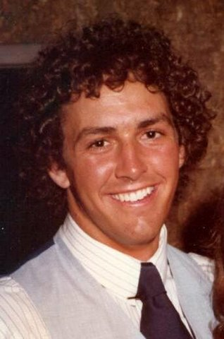
The scholarship is named in memory of Dallas Ward, son of Grady & Barbara Ward who raised purebred Angus cattle in Upper Cleveland County. Dallas was an exceptionally optimistic, talented, and caring young man. He competed in a variety of sports from age six through college, played the saxophone and oboe, and excelled as a student. Dallas was active in church and civic activities and demonstrated heart-felt compassion for all living things. His goal in life was to become a veterinarian. While a junior majoring in animal science at NC State University, Dallas was killed in a tragic automobile accident. Since 2004, more than $60k and 80 awards have been made to deserving students pursuing college degrees in fields of study related to agriculture.

Eligibility
- Graduating seniors from any of the high schools in Cleveland County pursuing a baccalaureate or associate degree who have demonstrated a strong interest in beef cattle production.
- Priority will be given to applicants who are associate members of CCCA or whose parents or grandparents are active CCCA members.
- Priority will be given to applicants who are pursuing a degree in agriculture with an emphasis in beef production.
- Previous winners may reapply and will be considered based on academic merit and financial need.

Selection Criteria
- Leadership and extracurricular activities
- Personal motivation and initiative
- Demonstrated interest in the beef cattle industry
- Career goals
- Academic standing
- Financial need

Administration
The scholarship will be administered by a Scholarship Committee composed of the Association president or his/her designee, the Association treasurer, an appointed Scholarship Committee chairperson, and the county extension director.
Instructions for completing the application:
This application provides information which will be used by the CCCA Scholarship Committee in making the award. To assure that you will be considered for this scholarship, please complete (type or neatly print) this form and submit it to:

CCCA Scholarship Committee
Attention: County Extension Director
130 S. Post Road, Suite 1
Shelby, NC 28152

For timely consideration, applications and all supporting documentation must be received by April 15.

Attach the following to the application:
- A 1- to 2-page essay which includes a biographical statement including family situation, special interests and activities, and any other pertinent information about yourself. This essay should also describe your college goals and future career plans. You may also include any background information (including an optional statement of financial need) that would assist the Selection Committee in evaluating your application.
- First-time applicants should include an official high school transcript with standardized test scores included.
- Three (3) letters of recommendation from teachers, civic, and/or faith community leaders(one letter must be written by a member of the Cleveland County Cattlemen's Association).

Returning Applicants:
College students reapplying for the award do not have to complete the application form. Instead, write a brief letter of interest that provides the Scholarship Committee with an update on your educational goals and career plans. Please enclose an official college transcript.

Application for the Cleveland County Cattlemen's Association
Dallas Ward Memorial Scholarship
Deadline: April 15 of each year

Personal Information
Applicant’s name:
Applicant’s age:
Home address:
City, State, Zip:
Telephone number:
School currently attending:
Parents’ name(s) & occupation(s):

Academic Information
GPA/Scale:
SAT Scores: | Verbal:  Math:
Class Rank & Size:
Have you applied for admission to an accredited college or university? | ☐ Yes  ☐ No
What school and intended major?
Have you been accepted for admission? | ☐ Yes  ☐ No
Have you applied for financial aid by submitting a FAFSA? | ☐ Yes  ☐ No

Estimated Annual Expenses
Tuition & Fees: | $
Room & Board: | $
Books & Supplies: | $
Other: | $

Additional Information
If you are receiving other scholarship awards for the upcoming academic year, please indicate the name and amount:
Extra-Curricular Activities:
Awards & Honors:

Community & Civic Affairs
List clubs, organizations, or major projects you have been involved in, including your leadership and volunteer service roles:

Work Activities
List employers, dates of employment, and work responsibilities:

Farm Activities
Is your family engaged in farming? | ☐ Yes  ☐ No
If so, what percentage of family income is derived from farming?
Nature of farming activity (crops and animals produced):
The nature and degree of your involvement in the farming operation:
If you have been involved in any cattle-related projects or activities, please describe:

Affirmation Statement:
All information contained in this application is, to the best of my knowledge, accurate and truthful. It is my understanding that to receive scholarships, I must be in good standing with my school. In accordance with the Family Educational Rights and Privacy Act, I authorize the CCCA Scholarship Committee to access my academic and disciplinary records for use in the scholarship decision-making process.

Signature:

Date:

Attachments:

☐ Official Transcript
☐ Essay
☐ Three letters of recommendation

